Gurjus Singh

# Assignment 4: Using a Dimensional Model with the SaleCO Data Warehouse

MSDS 420 Database Systems and Data Preparation

May 24th, 2020

1. SELECT c.cus_code,r.reg_name, (f.sale_units*f.sale_price) as Totalsales

FROM dwcustomer as c, dwregion as r ,dwdaysalesfact as f WHERE c.reg_id = r.reg_id and c.cus_code= f.cus_code

ORDER BY r.reg_name, c.cus_code;

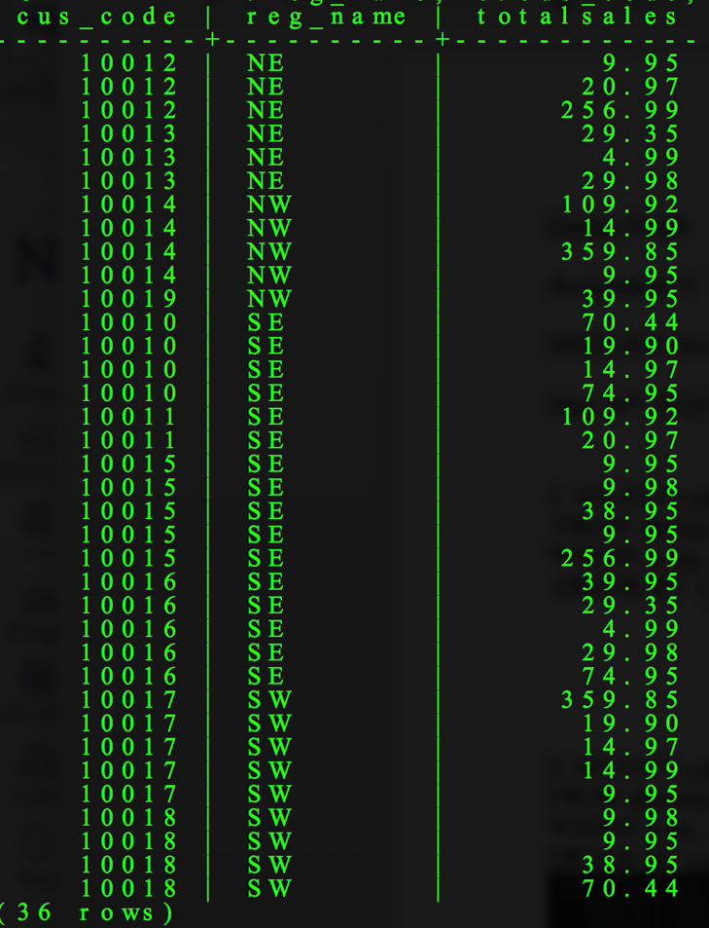

2. SELECT c.cus_code, p.p_code, t.tm_month, (p.sale_units*p.sale_price) as Totalsales FROM dwcustomer as c, dwdaysalesfact as p, dwtime as t

WHERE p.tm_id = t.tm_id AND c.cus_code = p.cus_code

ORDER BY c.cus_code, t.tm_month;



3.

A.)

SELECT c.cus_code, c.cus_fname, c.cus_lname, (p.sale_units*p.sale_price) as Totalsales FROM dwcustomer as c, dwdaysalesfact as p, dwtime as t

WHERE p.tm_id = t.tm_id AND c.cus_code = p.cus_code AND t.tm_month = 9 ORDER BY Totalsales DESC;

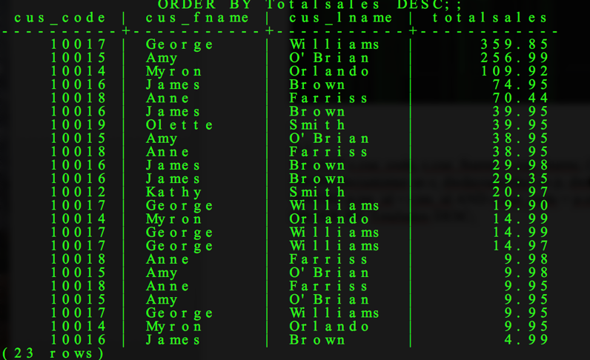

B.) SELECT c.cus_code, c.cus_fname, c.cus_lname, (p.sale_units*p.sale_price) as Totalsales FROM dwcustomer as c, dwdaysalesfact as p, dwtime as t

WHERE p.tm_id = t.tm_id AND c.cus_code = p.cus_code AND t.tm_month = 10 ORDER BY Totalsales DESC;

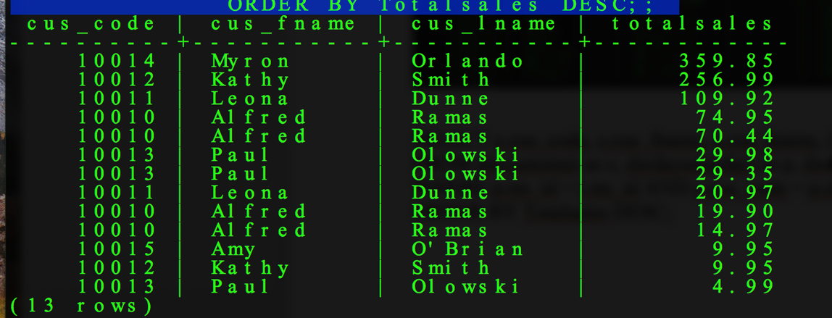

C.)

SELECT c.cus_code, c.cus_fname, c.cus_lname,SUM (p.sale_units*p.sale_price) as Totalsales

FROM dwcustomer as c, dwdaysalesfact as p, dwtime as t

WHERE p.tm_id = t.tm_id AND c.cus_code = p.cus_code AND t.tm_month IN (9,10) GROUP BY c.cus_code

ORDER BY Totalsales DESC;

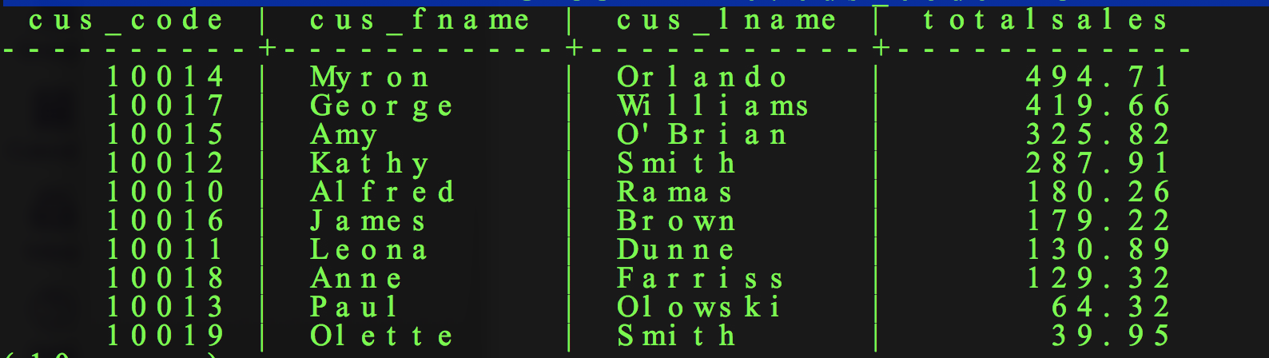

4.) SELECT t.tm_month, p.p_category, SUM(f.sale_units*f.sale_price) as Totalsales

FROM dwdaysalesfact as f, dwproduct as p, dwtime as t

WHERE f.tm_id = t.tm_id AND f.p_code = p.p_code

GROUP BY t.tm_month, p.p_category

ORDER BY t.tm_month, p.p_category;

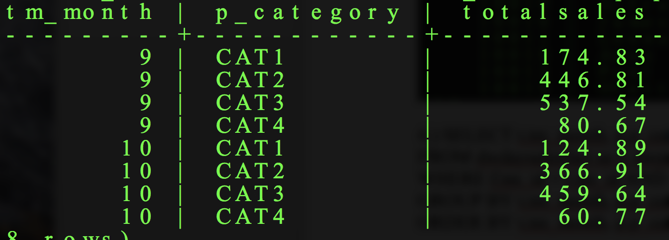

5.)

SELECT t.tm_month, count(p.p_code) as num_rows, SUM(f.sale_units*f.sale_price) as Totalsales

FROM dwdaysalesfact as f, dwproduct as p, dwtime as t

WHERE f.tm_id = t.tm_id AND f.p_code = p.p_code

GROUP BY t.tm_month

ORDER BY t.tm_month;

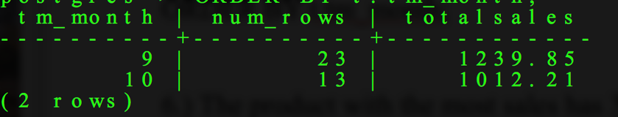

6.) The product with the most sales has 34 units sold which is a PVC pipe, 3.5 inch, 8-ft.

A.) SELECT p.p_code, p.p_category, p.p_descript,

SUM(f.sale_units) as unitssold FROM dwdaysalesfact as f, dwproduct as p, dwtime as t

WHERE p.p_code = f.p_code AND f.tm_id = t.tm_id AND t.tm_month = 9

GROUP BY p.p_code, p.p_descript, p.p_descript;

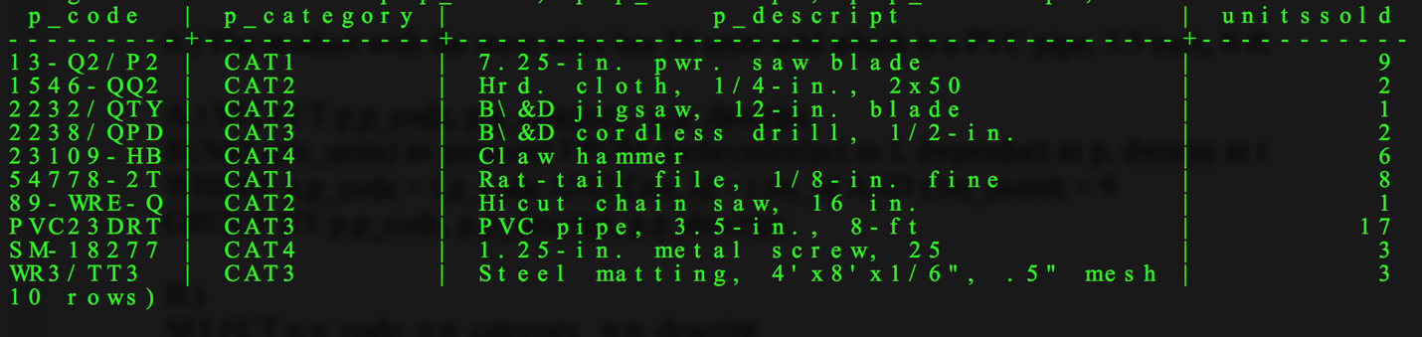

B.)

SELECT p.p_code, p.p_category, p.p_descript,

SUM(f.sale_units) as unitssold FROM dwdaysalesfact as f, dwproduct as p, dwtime as t

WHERE p.p_code = f.p_code AND f.tm_id = t.tm_id AND t.tm_month =10

GROUP BY p.p_code, p.p_descript, p.p_descript;

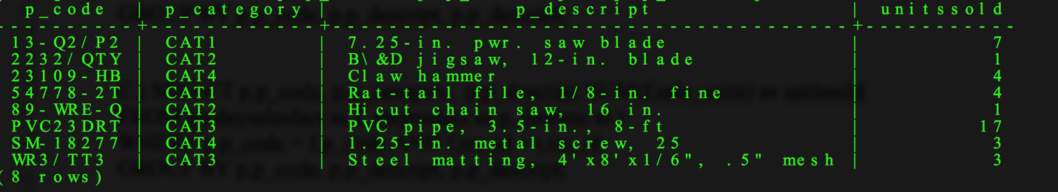

C.) SELECT p.p_code, p.p_category, p.p_descript, SUM(f.sale_units) as unitssold

FROM dwdaysalesfact as f, dwproduct as p, dwtime as t

WHERE p.p_code = f.p_code AND f.tm_id = t.tm_id

GROUP BY p.p_code, p.p_descript, p.p_descript;

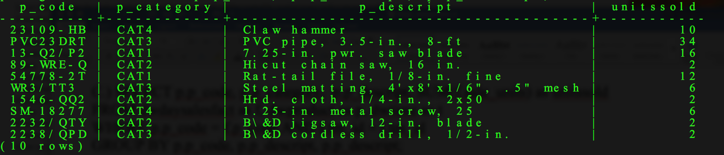

7.)

SELECT t.tm_month, p.p_category, p.p_descript, count(p.p_descript) as num_rows, SUM(f.sale_units * f.sale_price) as totalsales

FROM dwdaysalesfact as f, dwproduct as p, dwtime as t

WHERE p.p_code = f.p_code AND f.tm_id = t.tm_id

GROUP BY t.tm_month, p.p_category, p.p_descript

ORDER BY t.tm_month, p.p_category, p.p_descript;

